PumpSave User’s Manual

Energy Savings Calculator
for Pump Drives

ACS55
ACS150
ACS310, ACS355
ACS550, ACH550, ACS580
ACS800, ACQ810, ACS880

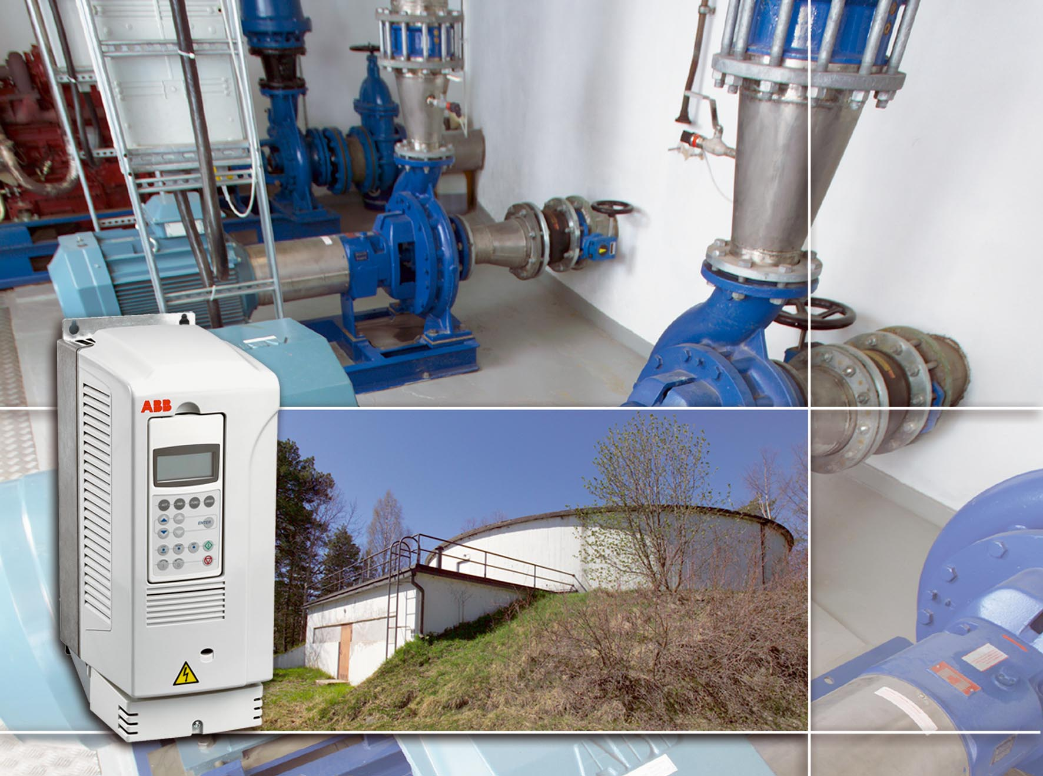

3AFE 64191691 REV M EN
Effective: 01.08.2012
Copyright © ABB Oy, Drives/TT

1 — General
PumpSave is a tool running on Microsoft Excel to calculate the energy savings available when using ABB variable speed AC drives instead of other pump control systems.

Comparisons are made with throttling control, ON/OFF control and adjustable speed control using a hydraulic or other type of slipping drive.

Calculations are based on typical centrifugal pump operating characteristics and some other assumptions. Consequently, the accuracy of the results is limited. The accuracy of the results is also affected by the accuracy of the input data. The results of this program must not be used as the basis for guaranteed energy savings. When more accurate computing is needed the DrivePump1.2 PC SW from ABB Drives is recommended.

Version 5.3
New general purpose drive ACS580 added.

Version 5.1
Added three languages and now supported languages are Chinese, Dutch, English, Finnish, French, German, Portuguese, Russian and Vietnamese.

Version 5.0
New industrial drive ACS880 added and the structure of worksheet changed from horizontal to vertical. The data inputs are on one page and following page is report. The vertical pages are supposed to be more user friendly supported by PageUp and PageDown of keyboard and scroll wheel of modern mouse.
Additionally the internal computing are made modern way. This anyway prevents the usage on older the 2007 Excels. The US style is supported later with US version.

2 — Starting and Running the Program

Software Required
Microsoft® Excel 2007 or later is required to run the energy calculation workbook. Also you shall enable the running of macros. The permanent settings for this are on Excel options/Trust center/Trust center settings/Marco settings.

Files Provided
The PumpSave files for pump drive calculations are incorporated into Excel workbook named originally PumpSave53.xlsm.

Installation
No installation is required but the workbook is can be copied to a hard disk and short-cut arranged to desktop.

Opening the Workbook
Start Excel as usual. For pump calculations open PumpSave53.xlsm.
You may adjust the Ribbon etc settings of Excel to get more space.
PumpSave will open with zoom setting 100% to get overview of input page, but you may zoom later on according to your preferences.

Disclaimer
At the end worksheet is the important disclaimer statement.
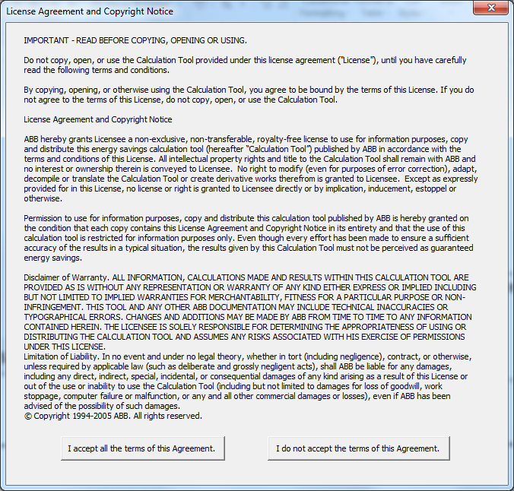

Worksheet
The language setting is on top right corner. The translated words and help texts are taken from Language sheet based on English keywords. This manual explains the English ones.



The Worksheet print will print a two page report by default.

3 — PumpSave worksheet inputs and results

General
All white fields on the sheet are for entering information and data Figure 1.
The sheet is filled in by default values to help users to right away find the idea of worksheet.

The small graph next to Pump data will illustrate the user inputs regarding nominal head, Max head and Static head. With this user will see if the input data is compatible.

The Results are displayed on second page Figure 2.
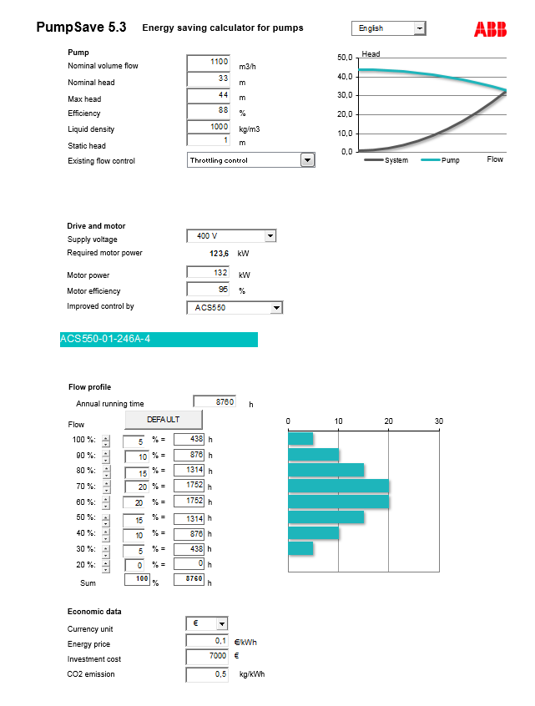

Figure 1 PumpSave input page

Input data
The required data includes pump data, existing flow control method, motor and supply voltage data and operating profile.

Economic data such as energy price and investment cost is required in order to get figures for investment appraisal.

Pump data

Nominal volume flow, Q_{n} (m3/h)
Enter the maximum system flow in cubic meters per hour, which the existing system will deliver and the pump must reach with existing control. PumpSave will assume that exactly the same flow has to be delivered also with AC drive. The energy saving calculation is based on flow rates that are equal to or less than Q_{n}.

Nominal head H_{n} (m)
Enter the head in meters that must be generated by the pump to produce the given nominal volume flow Q_{n} considering the system curve. The value must be determined from the pump curve and system curve intersection. One assumption which PumpSave makes is that the system curve with existing control and AC Drive control are the same. In reality this is seldom the case. In DrivePump SW the two are separate values.

Maximum head H_{max} (m)
Enter the max head that will be developed by the pump at full speed and zero flow. The value must be determined from the pump curve. If the pump curves look complicated select a H_{max} which together with H_{n} define a nice second order curve in the range 20….100% Q_{n}.

Efficiency, η_{p} (%)
Enter the efficiency of the pump at volume flow Q_{n} . The efficiency value should be given with the impeller which will be used.

Liquid density, ρ (kg/m3)
Enter the density of the liquid at the pump inlet in kilograms per cubic meter. The density of water is 1000 kg/m3.

Static head, H_{st} (m)
The static head is the difference between the static pressure at the pump discharge and the static pressure at the pump inlet but converted to head. It is the net distance that the pumped fluid is lifted, but additionally the pressure (liquid and gas) in the container has to be taken into account while determining the static head.

Existing Flow control
Pick the existing control method that you want to compare with ABB AC Drive control. The control method is selected from the drop-down list on the upper left part of the sheet. The options are throttling, on/off control, and hydraulic control.

The smaller energy usage of frequency converter is compared to a large energy required by:
• Throttling which means the liquid flow control is made by throttling valve and motor and pump is running at full speed and pressure.
• ON/OFF which means ON/OFF duty is adjusted according to flow requirements and a reservoir is available. The control can’t be as good as with speed control. When pump and motor is running they run at full speed.
• Hydraulic which is based on hydraulic drive or some other type of slipping drive such as an eddy current magnetic coupling drive. The motor is running with full speed but with slip the pump shaft is controlled.

Drive and Motor Data

Supply voltage
Enter the reference supply voltage to be used. The value should be between 115 (1-ph) to 690 V (3-ph). This is used to screen out drive types.

Required motor power
PumpSave is computing from pump data the required motor output power including 10% thermal margin. Based on this number you shall enter the Motor power.

Motor power (kW)
Enter the nameplate power rating of the motor. This is used to select the proper drive rating. The program uses calculated power demand to determine energy savings.

Motor efficiency, η_{m} (%)
Enter the motor efficiency from the motor nameplate or from other data supplied by the motor manufacturer. Use the efficiency for full load operation on fixed frequency utility power. The program will adjust the efficiency for operation at reduced speeds and loads. If the motor is oversized for the application, enter the efficiency for operation at the maximum applied load.

Improved control by
User should select the drive family from drop down box. PumpSave will pick the drive rating based on motor power and voltage.

Flow profile

Annual running time
In other words, this is the total operating time per year (h). Enter the number of hours that the pump is expected to run during a year’s time. For 24 hour, 365-day operation, enter 8760 hours.

Operating Time at Different Flow Rates (%)
Enter the estimated time as a percentage of the total operating time for operation at each of the listed flow rates from 100% to 20%. Enter zero for flow rates that are not used. The sum of the entered percentages shall be 100%. A figure under the white cells show the sum. If it is not 100, a comment “Sums must equal 100%” is shown.

Economic Data

Currency unit
Specify here the currency to be used in calculations.

Energy price (per kWh)
Enter the price of energy per kilowatt-hour (kWh). The PumpSave program does not have provisions for calculating demand charges. To estimate energy cost including demand charges, enter the average cost of energy per kWh including average demand charges. Please consider the rising energy prices.

Investment cost
Enter the estimated additional cost of purchasing and installing a variable speed AC drive as compared to the alternative method of flow control used in the comparison. Use the same currency units as entered for energy cost. This entry will be used to calculate the direct payback time. If the existing system needs costly maintenance cost compute the net present value of those and deduct from investment amount.

CO2 emission (kg/kWh)
This value shall reflect the local conditions: the emission per kWh.

Results
The results of the calculations include the estimated annual energy consumption for the existing control method and for AC drive control, the difference of these two, which equals the annual energy saving.
PumpSave also estimates the reduction in carbon dioxide (CO₂) emissions due to the reduced electricity consumption.
Payback period is calculated for the investment in the drive as compared to the alternative method of flow control.

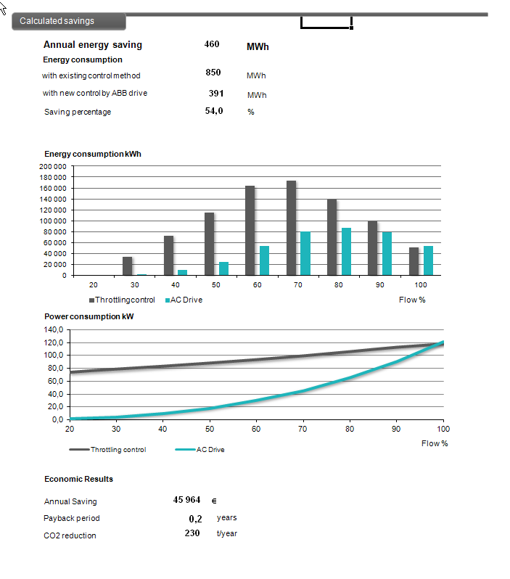

Figure 2 PumpSave results page

Calculated savings

Annual energy saving (MWh)
This is the energy difference in favor of frequency converter control.

Energy consumption (MWh)
These are shown for both with existing control method and new control methods.

Saving percentage
The reduction in electricity costs in percents. This is also, of course, the energy saving in percents.

Energy consumption – graph (kWh)
The calculated energy used annually with the two control methods are shown as function of flow.

Power consumption – graph (kW)
The calculated power demand with the two control methods are shown as function of flow.

Economic results

Annual Saving
This is how much money you save thanks to the variable speed control by AC drive annually. Money saving comes in the form of smaller electricity bill.

Payback period
This direct payback time shows how soon the savings cover the investment cost.

Annual CO₂ reduction (t/year)
This is the reduction in tons per year, which results from the reduced energy consumption due to variable speed control.

5 — Explanation of Calculations
In this chapter, the formulas behind PumpSave calculations are presented. The formulas use metric units. If the user enters the data in US units, PumpSave converts it to metric units first. The conversion factors are given in the end of this manual.

Pump operating point
The formula for the pump curve estimate used in calculations is:
This might be somewhat erroneous to submersible and high characteristic speed pumps etc.

Respectively, the system curve used in calculations is
A pump will always operate where these curves intersect, as Graph 1 shows.
Please notice that the point defined by H_{n} and Q_{n} is assumed to be known and valid for pump and system curve.

PUMP
SYSTEM
H_{max}
H_{N}
H_{st}
H_{dyn}
Q_{N}
pump curve, H_{pi}=H_{max}-(Q_{i}/Q_{n})^{2.}(H_{max}-H_{n})
system curve, H_{si}=H_{st}+(Q_{i}/Q_{n})^{2.}(H_{n}-H_{st})

Graph.1. Typical pump and system curves.

When adjusting the pump speed to control the volume flow, the process moves via system curve Hsi. Respectively, when throttling the pipeline the pump operates continuously at the same speed, and the movement of the process is via pump curve Hpi.

Pump drive calculations
The nominal shaft power of a pump is calculated from the formula
In the calculation sheets, calculations are at single points for Q = 20% to 100% of nominal pump flow Qn. Q is the actual flow. H is the total dynamic head at flow Q. The efficiency figures are multiplied with k-factors witch take into account operating conditions with some accuracy. These correcting factors are defined based on experience.

Efficiency
η
Flow Q
PUMP
DRIVE
MOTOR
100 %
95 %
80 %
η_{vsd}
η_{m}
η_{p}

Graph 2. Typical efficiencies.

This gives the following formulas for power calculations:

Frequency converter control

, where

Throttling control, assuming constant motor efficiency

, where

ON/OFF control, assuming constant motor and pump efficiency

Hydraulic control,

, where

The rated efficiency of hydraulic coupling is assumed to be 98%.

The required power for the compared control method is calculated and the energy consumption per year is thereafter calculated from the formula

Unit Conversions
Please use the conversion tools found on Web to work with local non SI -units.

